Geography Policy

Introduction

This policy sets out our school’s aims and strategies for the successful delivery of geography. This policy should be read in conjunction with other relevant school policies, such as curriculum, teaching and learning, equal opportinuties, SEND and assessment policies. This policy is based on government recommended/statutory programmes of study.

Aims:

‘A high-quality geography education should inspire in pupils a curiosity and fascination about the world and its people that will remain with them for the rest of their lives. Teaching should equip pupils with knowledge about diverse places, people, resources and natural and human environments, together with a deep understanding of the Earth’s key physical and human processes. As pupils progress, their growing knowledge about the world should help them to deepen their understanding of the interaction between physical and human processes, and of the formation and use of landscapes and environments. Geographical knowledge, understanding and skills provide the frameworks and approaches that explain how the Earth’s features at different scales are shaped, interconnected and change over time.’ National Curriculum 2014

Outstanding Geography teaching aims to:
- Inspire in pupils a curiosity and fascination about the world and its people that remain with them for the rest of their lives.
- Provide children with the geographical knowledge and skills needed for future learning and employment.
- Equip pupils with knowledge about diverse places, people, resources and natural and human environments, together with a deep understanding of the Earth’s key physical and human processes.
- Develop a growing knowledge about the world to deepen their understanding of the interaction between physical and human processes, and of the formation and use of landscapes and environments.
- Acquire and retain Geographical knowledge, understanding and skills that continue to develop cumulatively throughout their learning journey.
- Enable children to learn and explain how the Earth’s features at different scales are shaped, interconnected and change over time.
- Develop an increasing awareness of how our actions affect the world.
- To develop graphicacy and visualisation skills that relate particularly to geography and mapping skills.
- Develop the language of geography through precise teaching of geographical vocabulary that builds throughout their journey at Stottesdon

Curriculum

Early Years
We teach geography as an integral part of the topic work covered during the year. We relate the geography aspects of the children’s work to the objectives set out in the Early Learning Goals (ELGs) which underpin the curriculum planning for children aged two to five. Geography makes a significant contribution to the ELG of developing a child’s knowledge and understanding of the world and community around them through a wide range of child initiated and adult led activities.

In EYFS, children begin to develop their geographical knowledge by exploring features of our school and nursery. Maps and atlases are used to investigate different places as we begin to compare and contrast different environments. Children have rich opportunities to make use of school grounds to enhance and apply their skills as geographers. Throughout the year, children observe and discuss the weather and seasonal changes. Children also learn about the different jobs which people do in our community.

Key Stage One and Two:
Our school has decided to use Rising Stars Geography as a scheme to underpin our intent and implementation for this subject at KS1 and KS2.

Rising Stars Geography provides a curriculum that is ambitious and designed for all pupils. It is coherently planned and sequenced towards cumulatively providing the necessary knowledge and skills for the pupils’ future to empower them to take their role as informed and active citizens in the 21st century. Its emphasis is not just on geographical knowledge but also skills and concepts. It has the same challenging academic ambitions for all pupils. They all work from a shared starting point to answer the same key questions.

There are half-termly units (3 per year) which have key geographical enquiry questions and a focus of key subject knowledge, concepts and vocabulary. An enquiry approach is used as a shared experience, with key and supplementary questions, to encourage curiosity, geographical thinking, exploration and research, and to combine relevant knowledge with skills. This hopefully mitigates against a didactic approach and encourages teaching and learning to become a joint pupil / teacher ‘adventure’ or ‘journey’. Pupils will often discover that some of the questions have more than one answer, some of which are ‘better’ than others. This is particularly true when environmental issues are discussed, and experts propose different solutions. Pupils can explore how ‘real world’ decisions are made.
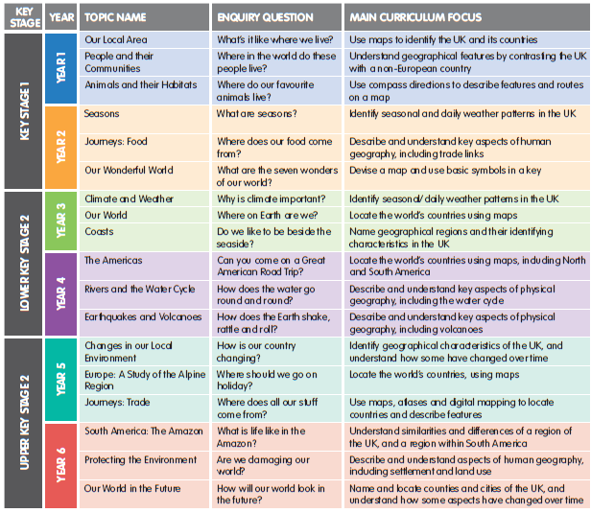

Skills, knowledge and understanding in geography progress through Year 1 to Year 6, being taught, developed and applied throughout the schemes of work. A range of opportunities are provided to enable all pupils to communicate their knowledge and understanding of the subject. Links are made within and across units to support pupils in making connections (please see the progression charts and our curriculum maps for more information) .

From Year 1 to Year 6 the scope of each unit increases, expanding from the pupils’ own environment to the wider world. Place studies start local and increase in scale to regional, national and global, allowing for revisiting, developing and challenging ideas and concepts. Similarly, consideration of the weather and seasons progresses to more in depth study of the importance of climate and
finally addresses protecting environments from global warming and combating
climate change. Some units are essentially human geography, other physical geography, but most
are holistic geography, considering human and physical geography together – the
real, undifferentiated world of the pupil.

Skills and knowledge are introduced then revisited in different units and in different contexts. This enables progression to be identified, planned for, developed and monitored. Skills are not taught in isolation for their own sake, but in interesting and appropriate contexts. By providing a starting point accessible to all pupils, they can each make their own progress along a geographical journey, some getting further than others. The progression sequence below helps facilitate this as it extends geographical knowledge, understanding and thinking.

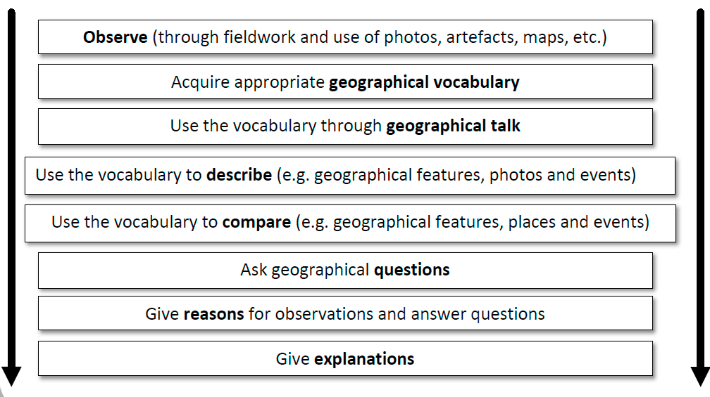

Assessment and reporting:
We use assessment for learning (AFL) during each session so as to understand where pupils are with their learning and therefore informing the next steps to be taught. Throughout the session, informal assessments are made in accordance with the learning objective and success criteria which have been identified as key areas of learning.
The assessment opportunities included in Rising Stars Geography are planned to have maximum impact on pupils while adding the minimum burden to teacher workload. Each unit has a key assessment opportunity which links with the Rising Stars Geography progression framework that is cross-referenced to the National Curriculum. It also links to the information contained in the Curriculum Coverage and Progression Charts. These assessment opportunities will enable the teacher to monitor progress made by individual pupils and review areas where the class or groups excels, or where areas of learning need to be revisited, developed and consolidated in a different context.

Formative assessment opportunities are integrated throughout the units. Some are informal and depend on the use of talk, eavesdropping on pupil-pupil discussion, or teacher-pupil conversation, checking that geographical vocabulary has been acquired, is understood and can be used correctly (associated with visual images where relevant). These opportunities check understanding, identify misconceptions, enable direct feedback and allow for adaptation without unnecessary elaboration or differentiation. Finally, an online end-of-unit quiz is also included in each unit. By their nature, these usually test retention of what has been taught, rather than geographical knowledge and understanding, although they could be used by the pupils as research exercises and challenges beyond the direct scope of the unit. They can also provide the teacher with a quick check on where an aspect of learning needs revisiting and reinforcing.

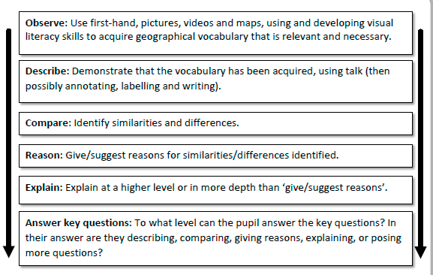
Some pupils will be able to progress through the whole sequence at the relevant level, achieving ‘the expected level’ or ‘exceeding expectations’. Others may get less far, making a start and achieving ‘working towards’, with the next step for them identified. The subject leader can also utilise the information to inform and further develop curriculum design, teaching approaches and resourcing. It can provide opportunities for moderation across classes and enable pupils to know how they are performing in the subject and what they need to do to achieve the next stage in their learning journey.
Reports are sent home, mid year and at end of the school year (twice yearly) alongside parent consultations in the Autumn and Spring terms to report attainment, progress and attitude to learning to parents.

Inclusion:
Geography is taught in line with our Equality Scheme. All pupils, regardless of race or gender, shall have the opportunity to develop their Geographic skills from the same starting points. Activities will be differentiated and amended where appropriate to ensure the inclusion and enjoyment of all children, including those with special educational needs.

Monitoring, evaluation and feedback:
Monitoring standards of teaching and learning within history is the primary responsibility of the history Leader and the whole teaching team.
Details of monitoring and evaluation schedules can be found in the School Development Plan.
Monitoring will be achieved through:
· Work scrutiny.
· Learning walks/’Deep Dives’.
· Observations.
· Pupil voice.
· Teacher voice.
· Reflective teacher feedback.
· Learning environment monitoring.

Safe practice and out-of-school opportunities:
All fieldwork within and outside of the school grounds is carried out in compliance with statutory requirements and recommendations laid out in the our Educational Visits Policy and Practice with Telford and Wrekin.

Date: 17th February 2023 Review: Feb 2026

