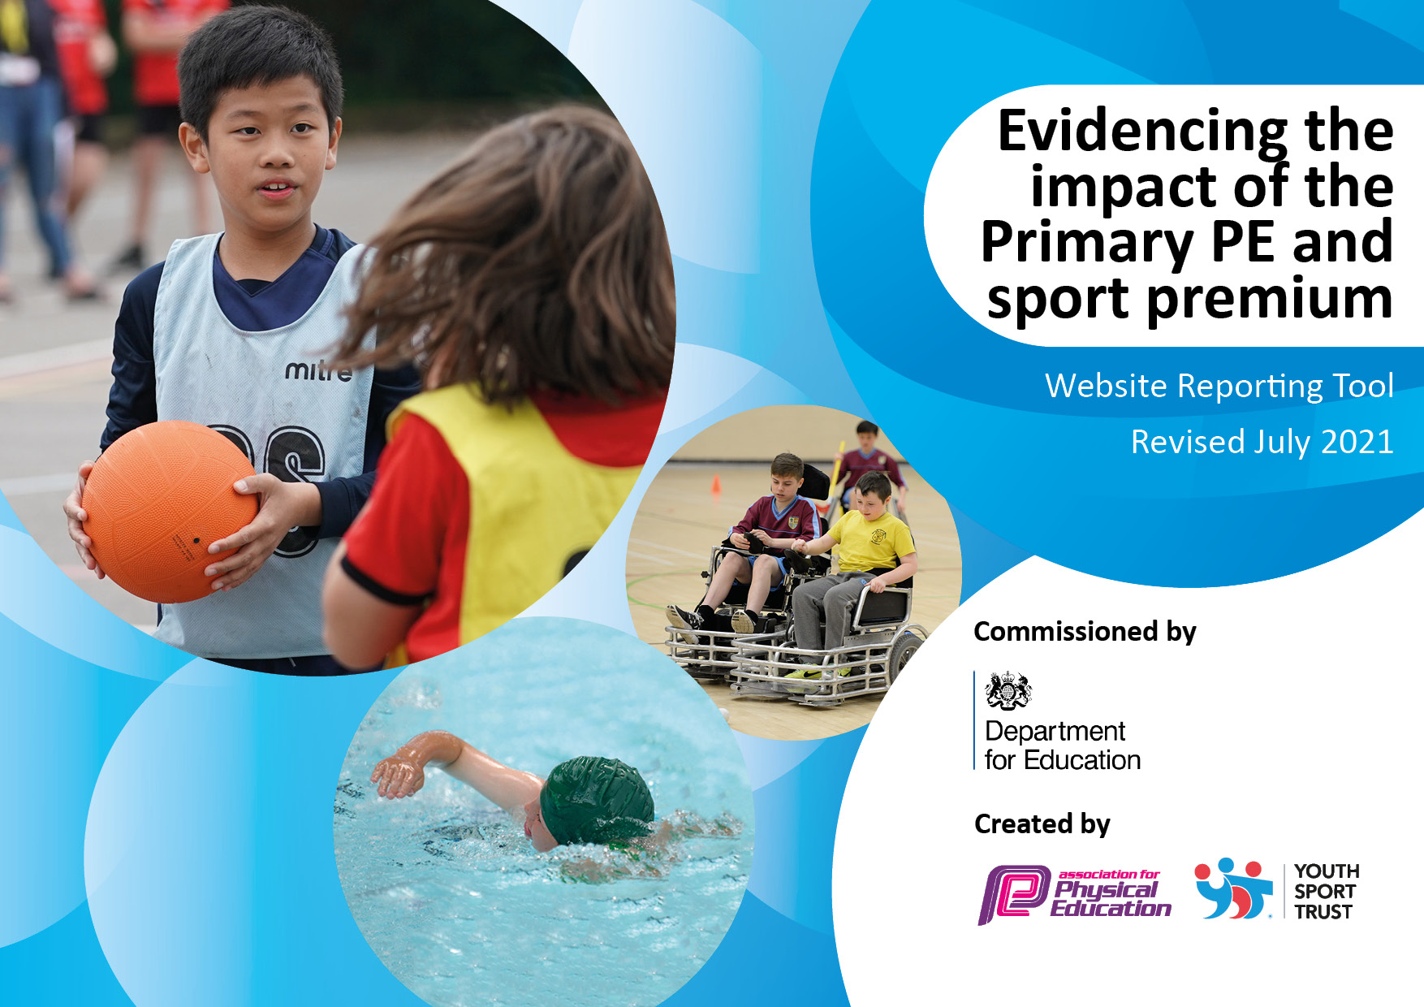
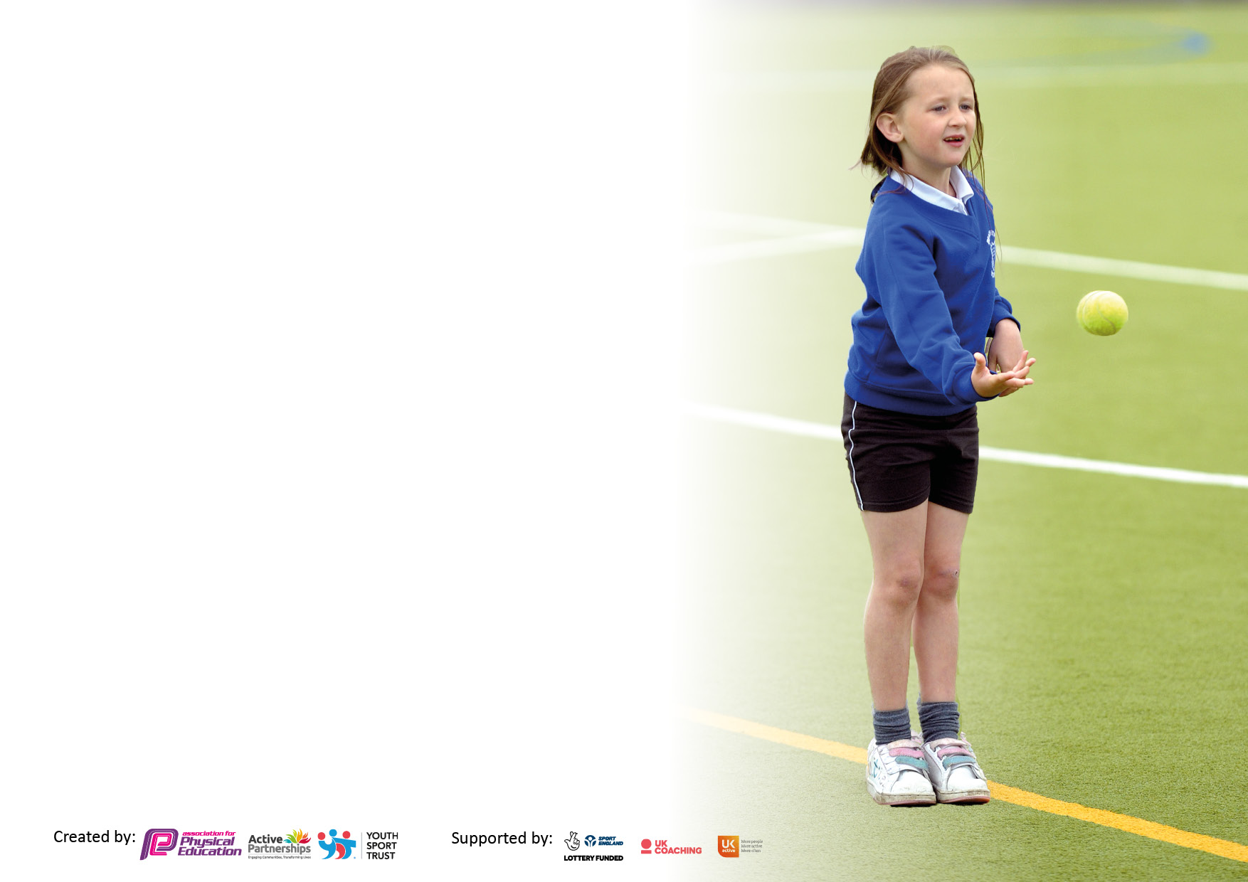

It is important that your grant is used effectively and based on school need. The Education Inspection Framework makes clear there will be a focus on ‘whether leaders and those responsible for governors all understand their respective roles and perform these in a way that enhances the effectiveness of the school’.

Under the Quality of Education Ofsted inspectors consider:
Intent - Curriculum design, coverage and appropriateness
Implementation - Curriculum delivery, Teaching (pedagogy) and Assessment
Impact - Attainment and progress

To assist schools with common transferable language this template has been developed to utilise the same three headings which should make your plans easily transferable between working documents.

Schools must use the funding to make additional and sustainable improvements to the quality of Physical Education, School Sport and Physical Activity (PESSPA) they offer. This means that you should use the Primary PE and sport premium to:

- Develop or add to the PESSPA activities that your school already offer
- Build capacity and capability within the school to ensure that improvements made now will benefit pupils joining the school in future years
- The Primary PE and sport premium should not be used to fund capital spend projects; the school’s budget should fund these.

Pleasevisitgov.ukfortherevisedDfEguidanceincludingthe5keyindicatorsacrosswhichschoolsshoulddemonstrate animprovement.Thisdocumentwillhelpyoutoreviewyourprovisionandtoreportyourspend.DfEencouragesschools to use this template as an effective way of meeting the reporting requirements of the Primary PE and sport premium.

We recommend you start by reflecting on the impact of current provision and reviewing the previous spend.

Schools are required to publish details of how they spend this funding, including any under-spend from 2019/2020, as well as on the impact it has on pupils’ PE and sport participation and attainment. All funding must be spent by 31st July 2022.

We recommend regularly updating the table and publishing it on your website throughout the year. This evidences your ongoing self-evaluation of how you are using the funding to secure maximum, sustainable impact. Final copy must be posted on your website by the end of the academic year and no later than the 31st July 2021. To see an example of how to complete the table please click HERE.

Details with regard to funding
Please complete the table below.

Total amount carried over from 2021/22 | £0
Total amount allocated for 2022/23 | £18,450
Total amount of funding for 2023/24. | £16,800
Swimming Data
Please report on your Swimming Data below.

Meeting national curriculum requirements for swimming and water safety.

N.B. Complete this section to your best ability. For example you might have practised safe self-rescue techniques on dry land which you can then transfer to the pool when school swimming restarts.
Due to exceptional circumstances priority should be given to ensuring that pupils can perform safe self rescue even if they do not fully meet the first two requirements of the NC programme of study
What percentage of your current Year 6 cohort swim competently, confidently and proficiently over a distance of at least 25 metres?  N.B. Even though your pupils may swim in another year please report on their attainment on leaving primary school at the end of the summer term 2022.  Please see note above | 100%
What percentage of your current Year 6 cohort use a range of strokes effectively [for example, front crawl, backstroke and breaststroke]?  Please see note above | 100%
What percentage of your current Year 6 cohort perform safe self-rescue in different water-based situations? | 100%
Schools can choose to use the Primary PE and sport premium to provide additional provision for swimming but this must be for activity over and above the national curriculum requirements. Have you used it in this way? | Yes/No  Access was provided for pupils in Y5/6 if they needed targeted support

Action Plan and Budget Tracking
Capture your intended annual spend against the 5 key indicators. Clarify the success criteria and evidence of impact that you intend to measure to evaluate for pupils today and for the future.

Academic Year: 2022/23 | Total fund allocated:£16,800 | Date Updated:
Key indicator 1: The engagement of all pupils in regular physical activity – Chief Medical Officers guidelines recommend that primary school pupils undertake at least 30 minutes of physical activity a day in school |  |  |  | Percentage of total allocation:
 |  |  |  | £3500 = 19%
Intent | Implementation |  | Impact
Your school focus should be clear what you want the pupils to know and be able to do and about what they need to learn and to  consolidate through practice: | Make sure your actions to achieve are linked to your intentions: | Funding allocated: | Evidence of impact: what do pupils now know and what can they now do? What has changed?: | Sustainability and suggested next steps:
- Pupils plan, deliver and participate in at least 15 mins active playtimes to support 30 active minutes  - All pupils have access to more organised activities at lunchtime and an opportunity to voice what activities are on offer. The take up is good and pupil voice indicates enjoyment  - Pupils are targeted with activities to involve and encourage the least active.  - Pupils show leadership in organising and officiating these opportunities (25% of Y3 – 6 )  - Zoned areas of the playground support both formal games and more creative games | Facilitate team practice 12- 12.30 for different sports. Audit school council, classes and target children for ideas.  Facilitate zoned areas on the playground for activities with older pupils acting as leaders (Jumping Jaxx training) or staff supporting as appropriate  Staff are supported in ideas for playground games and roles and responsibilities assign people to either formal games or creative games  Playground markings are updated and support choices | TA support ½ an hour a day  £600  Proportion of £4500 (Lacon Childe Partnership) - £900  PD day  £1000 +FOSPS contribution | .Active playtimes are in place. Pupils have fed preferences into the programme and acted as playleaders. Take up has been high with the vast majority of KS2 wanting to be involved.  Playground zones are in place with appropriate equipment and well used.  Playground markings haven’t been updated. The school was hoping to be successful in a grant application in order to do mile run footprints and goal post replacement. Unfortunately grant was unsuccessful. Opportunities in 23/24 will be explored | Continue programme – now established.  Consider playground facilities updates: goal posts; mile run footprints; other zone lines.
- All pupils participate in 15 mins daily mile | Classes run daily mile or 15min fitness drills.  Mile run line is installed | £1000+FOSPS contribution | Regularly in place and school is now considering school shoe uniform recommendation so children don’t have to change footwear for the mile run. | School uniform signposts to footwear which would be appropriate to run the mile run without having to change.

Key indicator 2: The profile of PESSPA being raised across the school as a tool for whole school improvement |  |  |  | Percentage of total allocation:
 |  |  |  | £2500 14%
Intent | Implementation |  | Impact
Your school focus should be clear what you want the pupils to know and be able to do and about what they need to learn and to consolidate through practice: | Make sure your actions to achieve are linked to your intentions: | Funding allocated: | Evidence of impact: what do pupils now know and what can they now do? What has changed? | Sustainability and suggested next steps:
- Everyone values their own and others enjoyment of sport, physical education and physical activity  - Lessons are active and consider engagement through varied activities that involve movement or use of different areas  - Pupils engage in active playtimes – see above  - Pupil engage in a varied festival and competition programme (see below) | - Sports board and regular information in the school news to celebrate and share  - Regular programme of sport and competition through the Lacon Childe Partnership.  - Continue to promote and remind about active lessons and playtimes  - Regular assemblies that celebrate sport or sporting achievements. | Leadership time below  Proportion of £4500 - £900 | Sports board regularly updated to celebrate sport.  Sports stars are celebrated each week in achievers’ assembly | Build expectations and engagement with SGO. Make strategic decisions about level 3 competition in order for it to be purposeful and manageable (cost of transportation)
- Sport, physical education and physical activity experiences are used across the curriculum | - To consolidate our vision with the whole school community and use our sporting experiences across the curriculum e.g English report writing; maths statistics; science etc | No cost  Staff meetings – curriculum map consideration | Some use but curriculum coverage is increasingly fine tuned. Links in science, PSHE are in place.
- Our small school has a ‘staff lead and champion’ just for sport  - Leadership capacity is developed | - Continue to develop leadership (TA) to co-ordinate provision and developments | £1600 Overtime and higher grade | This really helps build capacity in our school as well as adding consistency and sustainability
- Actively encourage pupils to take on leadership or volunteer roles that support the delivery of sport and physical activity within the school (such as ‘sports leader’ or peer-mentoring schemes) | - See key indicator one |  | Sport leaders in our school formally help run intra house competitions and sports day activities. Pupils informally step into roles on the playground. PE lessons include leadership roles and peer mentoring activities.

Key indicator 3: Increased confidence, knowledge and skills of all staff in teaching PE and sport |  |  |  | Percentage of total allocation:
 |  |  |  | £5150 28%
Intent | Implementation |  | Impact
Your school focus should be clear  what you want the pupils to know  and be able to do and about  what they need to learn and to  consolidate through practice: | Make sure your actions to  achieve are linked to your  intentions: | Funding  allocated: | Evidence of impact: what do pupils now know and what  can they now do? What has changed?: | Sustainability and suggested  next steps:
Nursery access more formal physical development sessions and core movement skills are targeted | KM advises and delivers physical development sessions. This supports staff professional development to lead sessions themselves.  Staff use of the outside area promotes physical literacy in a range of ways – staff meetings for training and SDP targets | Teacher across EYFS £2250 (as plan exceeds funding this is where school part funds)  EYFS staff meetings  Resources to support physical literacy as appropriate- £500 | Curriculum maps at EYFS have been tightened in defining key skills and knowledge. Use of the outside area has significantly improved (impact of CPD). | To continue to build staff confidence to create follow on opportunities following KM led sessions.
Provision in weaker areas is scaffolded as staff are supported with quality resources e.g. dance, OAA | Collate and signpost to support resources | £1000 for scheme consideration/resources | Good impact on specific dance units. Consideration of a scheme still ongoing | Consideration of a PE scheme
Pupils know more and are able to do more as a result of specific, high – quality provision  An increasing percent of pupils achieve skills on the assessment sheets. | - The % of children at secure increases with the following areas targeted  - Hitting and striking skills at KS1  - Securing games skills at KS2 – now strong by the end of yr 6. Y5 may need some targeting. Y4 data missing? Good development at Y3  - Consider specialised dance provision.  - Consider OAA in all year groups  - Scaffold consistency of teaching and learning with quality assessment resources - Use trust PE skills tracking grids consistently across personnel  - Partnership delivering lessons alongside teachers through the year  - Staff to access gymnastic and dance training | Leadership cost above.  Proportion of £4500 - £900  £500 PE CPD | Outcomes are clear each half term. Increasing numbers of pupils securing skills.  Communication of foci between teachers and coaches is good. | There has been good use of the skills tracking sheets but the following areas would now benefit from focus:  - Fine tuning the areas in line with any reviews of our curriculum  - Targeting of the Y5 cohort (Y6 next year)  - Confirming our OAA offer  - Confirming specialised provision for the next year.  - Facilitating time for tracking data to be completed

Key indicator 4: Broader experience of a range of sports and activities offered to all pupils |  |  |  | Percentage of total allocation:
 |  |  |  | £3100 17%
Intent | Implementation |  | Impact
Your school focus should be clear  what you want the pupils to know  and be able to do and about  what they need to learn and to  consolidate through practice: | Make sure your actions to  achieve are linked to your  intentions: | Funding  allocated: | Evidence of impact: what do pupils now know and what can they now do? What has changed?: | Sustainability and suggested  next steps:
- A wider range of sporting activities are available and pupils take these up.  - There is a programme of activity after school daily which is popular with the children.  - At least 60% participate in extra-curricular every week (Y3 – 6 but also aim for the whole school)  - Celebrate and value what children do outside school activities so this is valued, promoted and shared.  - 85% of pupils participate in extra-curricular sport every week (in or outside of school) | Lacon Partnership Out of school hours learning  Partnership with wider providers and key clubs e.g. Bridgnorth Tennis; Kiddy Harriers Football; Worcs Warriors Rugby; Dance; Gymnastics  Transport of pupils to other venues supports the range of experiences and quality of provision (e.g. gymnastics)  Continue to broaden the school activities and more regularly make these open to pupils who attend wrap around.  Signpost to a range of community providers – website – school news – visiting coaches – celebrate pupil attendance | Proportion of £4500 - £900  C£200 for a half term programme – consider 1 each term = £600  Upper KS2 1 half term set of lessons -= £600  Funded by parent contributions + £500 top up to keep costs accessible and inclusive of wrap around. Funding attendance to some activities in order to boost initial uptake | Having accessible data and managing workload became challenging as the year progressed. However the following estimates emerged:  - Around 75% of KS2 accessed extra curricular activity each week. We feel that the 85% target has been achieved but need manageable tools to evaluate this.  - A questionnaire is gauging what children do outside school is in progress  - Local sports clubs are signposted on the school website and we continue to use partners in our provision | To move administration and booking of clubs to Arbor so data can be more easily and strategically managed and evaluated.  Move to regular questionnaires to evaluate offers and gauge what children are doing outside of school
- OAA tracking on assessment sheets shows good coverage and achievement  - All children access orienteering opportunities through Live the Adventure or other outlet or onsite provision. Pupils enjoy being outdoors and understand how this relates to mental and physical health. | All classes access orienteering activities to achieve skills identified for their year group.  PE leader considers options to achieve this | Funded by voluntary contributions and £500 allocation (forest Fun spend) | - Accessing OAA has been challenging (cost)  - EYFS have good access to Forest Fun provision. | - To confirm our OAA offer

Key indicator 5: Increased participation in competitive sport |  |  |  | Percentage of total allocation:
 |  |  |  | £4200 23%
Intent | Implementation |  | Impact
Your school focus should be clear | Make sure your actions to | Funding | Evidence of impact: what do | Sustainability and suggested
what you want the pupils to know | achieve are linked to your | allocated: | pupils now know and what | next steps:
and be able to do and about | intentions: |  | can they now do? What has
what they need to learn and to |  |  | changed?:
consolidate through practice:
All pupils access a broad programme of Level 1, Level 2 and (where appropriate) Level 3 competition. This supports enjoyment and develops skill. | - Pupils participate in a comprehensive programme of sport and events  - Increase the intra school sport activities each term e.g. class or house competitions  - Increase idea of competition against self with personal best records e.g. in Athletics  - Track achievements on assessment grids  - Consider access to level 3 competition based on costings/funding | Proportion of £4500 - £900  £3300 Transportation to the programme.  KS2 c. 2 x per half term- £2400  KS1 c 1 x per half term - £600  Reception c 1 per term - £300 | Pupils have participated in a comprehensive programme of sports and events and met school games Gold. Level 3 competition is clarified and we are moving to prioritising these opportunities and transport costs. Liaison with SGO is improving. | Continue to build effective liaison with SGO and facilitating 4 level 3 competition pathways (cricket, netball, athletics, tag rugby)

Signed off by
Head Teacher: | Katie Jones
Date: | November 2023
Subject Leader: | Tracey Wood
Date: | November 2023
Governor: | Chris Tibbet
Date: | November 2023

